Step1 ) Create an include program. The Type of program should be include.

Step2 ) The include program should have the following contents

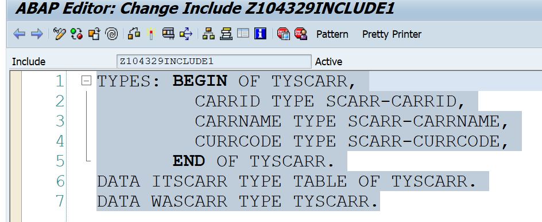

Step 3) Include the program in any editor program

